**LAB ASSIGNMENT - 5**

By

Seshasai P B-21MIA1005



SCOPE SCHOOL VIT CHENNAI CAMPUS, VANDALUR-KELAMBAKKAM ROAD, CHENNAI-600127

DATE: 17-10-2024

STUDENTS: Students of IV year M.TECH (5 YEARS)

Submitted To: Dr. Saranyaraj D

Github_link: <https://github.com/the-seshasai/lab7_iva>

**Task-1**

**Objective**

The objective of this assignment is to create a robust image processing system that performs **motion estimation** and **event detection** using grayscale video frames. The system aims to:

1. **Estimate Motion**: Identify areas of movement between consecutive frames by computing pixel differences.
2. **Highlight Moving Regions**: Visually emphasize the regions in the frames where motion occurs.
3. **Detect Events**: Use histogram-based analysis to detect significant changes between frames, identifying these changes as events.
4. **Annotate and Log Events**: Mark detected events with event numbers and timestamps, and store these annotated frames and event details in output directories.

The main goal is to analyze video data, track motion, and detect notable changes in video sequences, which are critical in areas like surveillance, traffic monitoring, and activity detection in videos.

**Problem Statement**

**Description of the Problem:**

The task is to develop a system that processes a sequence of grayscale video frames to:

1. **Estimate motion** by computing the pixel-wise difference between consecutive frames. This helps in identifying regions of movement within the video.
2. **Highlight moving regions** in the frames, marking areas where significant motion occurs.
3. **Detect significant events** by analyzing the differences between the histograms of consecutive frames. Large changes in the histograms indicate notable events, such as sudden movement or changes in lighting conditions.
4. **Annotate events** with timestamps and event numbers on the frames, providing a clear visual representation of when and where the event occurred.

The system should be capable of:

* **Processing a sequence of video frames** to compute motion and detect events.
* **Highlighting moving areas** within frames, using color-coding to differentiate them from static regions.
* **Detecting significant events** based on a threshold for histogram changes, which signal a notable shift between frames.
* **Saving outputs** in the form of motion-highlighted frames, event-annotated frames, and logs containing motion estimation values and event timestamps.

**Expected Output:**

1. **Motion-Highlighted Frames**: Each frame should display moving areas highlighted in red to visually show motion.
2. **Event-Annotated Frames**: Frames where significant events are detected should be annotated with event numbers and timestamps.
3. **Motion Estimation Log**: A text file (motion_estimation.txt) storing the motion estimation values between frames.
4. **Event Timestamps Log**: A text file (event_timestamps.txt) storing the timestamps of detected events.
5. **Histograms**: Histograms of pixel intensity distribution for each frame, saved as images, to visualize the pixel value distribution in each frame.

**Methodology**

The methodology involves a systematic approach to processing video frames for motion estimation and event detection. This section includes a detailed description of the steps involved, a block diagram for clarity, and pseudocode for the algorithm.

**Steps Involved:**

1. **Frame Loading**: Load a sequence of grayscale video frames from a specified directory.
2. **Motion Estimation**: Compute the pixel-wise differences between consecutive frames to estimate the amount of motion between them. This will highlight areas where significant movement is happening.
3. **Thresholding for Motion Detection**: Apply a threshold to the pixel difference to isolate regions with noticeable motion.
4. **Frame Highlighting**: Convert the grayscale frames into color and highlight moving regions in red.
5. **Histogram Comparison for Event Detection**: Calculate the histogram of pixel intensities for each frame and compare it with the histogram of the previous frame. If the difference exceeds a predefined threshold, it is considered a significant event.
6. **Annotate Events**: When an event is detected, annotate the frame with an event number and timestamp.
7. **Save the Results**: Save the highlighted motion frames, event-annotated frames, and logs of motion estimation and event timestamps.

**Block Diagram:**

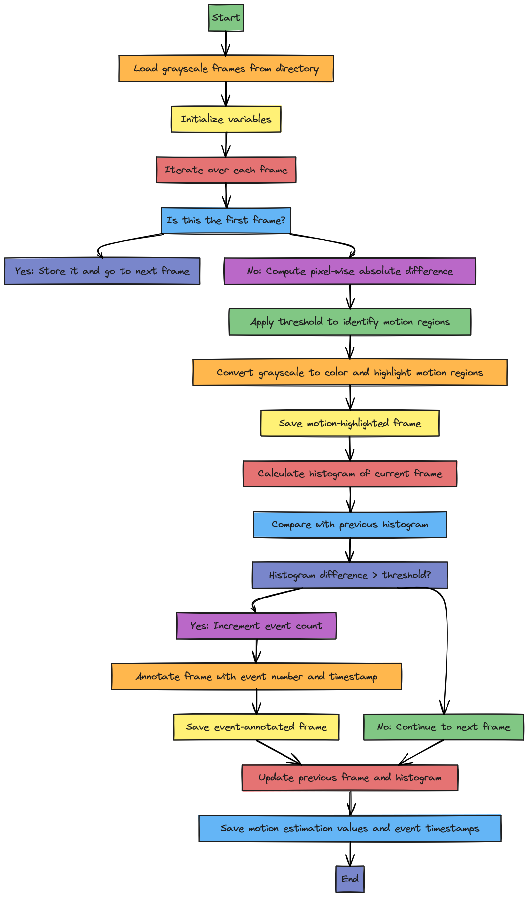

**Algorithm:**

1. **Input**: Directory of grayscale video frames.
2. **Output**: Motion-highlighted frames, event-annotated frames, motion estimation values, and event timestamps.

**Step 1:** Load all grayscale frames from the specified directory.

**Step 2:** Initialize variables: previous_frame, previous_hist, event_count, timestamps.

**Step 3:** For each frame:

a. If this is the first frame, store it and continue to the next frame.

b. Compute the pixel-wise absolute difference between the current frame and the previous frame.

c. Apply a threshold to the difference to identify motion regions.

d. Convert the grayscale frame to a color frame and highlight the moving regions in red.

e. Save the highlighted motion frame.

f. Calculate the histogram of the current frame and compare it with the histogram of the previous frame.

g. If the histogram difference exceeds a predefined threshold:

i. Increment the event count.

ii. Annotate the frame with the event number and timestamp.

iii. Save the annotated event frame.

h. Update the previous frame and histogram for the next iteration.

**Step 4:** Save the motion estimation values and event timestamps to text files.

**Pseudo Code**:

# Load the frames from the directory

for each frame in the directory:

    if it's the first frame:

        store it as the previous frame

        calculate the histogram of the frame and store it as the previous histogram

        continue to the next frame

    # Compute the absolute difference between the current frame and the previous frame

    difference = abs(current_frame - previous_frame)

    # Apply a threshold to the difference to highlight motion regions

    thresholded_frame = threshold(difference)

    # Convert the grayscale frame to a color frame and highlight moving regions in red

    highlighted_frame = color_frame_with_highlights(thresholded_frame)

    # Save the highlighted frame

    # Calculate the histogram of the current frame and compare it with the previous frame's histogram

    current_histogram = calculate_histogram(current_frame)

    histogram_difference = compare_histograms(previous_histogram, current_histogram)

    # If the histogram difference exceeds the event threshold, mark it as an event

    if histogram_difference > event_threshold:

        event_count += 1

        annotate_frame(highlighted_frame, event_count, timestamp)

        save_annotated_frame()

    # Update previous frame and histogram for the next iteration

    previous_frame = current_frame

    previous_histogram = current_histogram

# Save motion estimation values and event timestamps

**Motion Estimation:**

Motion estimation is performed by computing the **absolute difference** between consecutive frames. This allows us to highlight areas of movement between the frames. The difference is thresholded to remove small changes (such as noise) and focus on significant motion.

**Event Detection:**

Events are detected using **histogram-based analysis**. For each frame, a histogram of pixel intensities is calculated. By comparing the histogram of the current frame with the previous frame, we can detect large changes in the video. If the difference exceeds a predefined threshold, an event is flagged. These events are usually triggered by significant changes in the scene, such as a person entering or leaving the frame, a sudden change in lighting, or any substantial motion.

**Thresholding for Motion Detection:**

A threshold value is used to highlight significant movement between frames. This threshold separates meaningful motion (such as a person walking) from minor changes (such as shadows or noise). The highlighted regions are displayed in red on the color-converted frames.

**Annotating Frames:**

When an event is detected, the frame is annotated with:

* **Event number**: Indicates the order of the detected events.
* **Timestamp**: The time at which the event occurred, calculated based on the frame index and the frames per second (FPS) of the video.

**Python Implementation**

**Directory Setup and Initialization**

import cv2

import os

import numpy as np

# Directory where grayscale frames are saved

frame_dir = 'frames'

highlight_dir = 'highlighted_motion_frames'

event_dir = 'annotated_event_frames'

os.makedirs(highlight_dir, exist_ok=True)

os.makedirs(event_dir, exist_ok=True)

**Explanation:** We import necessary libraries and define the directories where the grayscale frames are stored, and where the motion-highlighted and event-annotated frames will be saved. We create the directories if they don’t already exist using os.makedirs().

**Parameters and Variables Initialization**

motion_threshold = 30  # For pixel differences

event_threshold = 50000  # For histogram-based event detection

fps = 30  # Frames per second

# Initialize variables

previous_frame = None

previous_hist = None

motion_estimation = []

event_count = 0

timestamps = []

**Explanation**: Here, we define the thresholds for motion detection and event detection:

* **motion_threshold:** Sets the threshold for pixel-wise differences between frames to detect motion.
* **event_threshold:** Defines a threshold for the histogram difference between consecutive frames to detect significant events.
* **fps:** Frames per second to compute timestamps.

We also initialize variables to store the previous frame, previous histogram, motion estimation values, event count, and timestamps.

**3. Frame Processing and Motion Estimation**

for i, frame_file in enumerate(sorted(os.listdir(frame_dir))):

    frame_path = os.path.join(frame_dir, frame_file)

    gray_frame = cv2.imread(frame_path, cv2.IMREAD_GRAYSCALE)

    if previous_frame is None:

        previous_frame = gray_frame

        previous_hist = cv2.calcHist([gray_frame], [0], None, [256], [0, 256])

        continue

    # Compute the absolute difference between the current frame and the previous frame

    diff_frame = cv2.absdiff(previous_frame, gray_frame)

    _, thresh_frame = cv2.threshold(diff_frame, motion_threshold, 255, cv2.THRESH_BINARY)

    # Convert the grayscale frame to color to highlight motion regions

    color_frame = cv2.cvtColor(gray_frame, cv2.COLOR_GRAY2BGR)

    color_frame[thresh_frame > 0] = [0, 0, 255]  # Highlight moving regions in red

**Explanation**:

* **Frame loading**: We iterate through the frames in the directory, load each one in grayscale, and if it's the first frame, we store it as the previous frame and compute its histogram.
* **Motion estimation**: For each frame, we compute the pixel-wise absolute difference from the previous frame to estimate motion. Then, we apply a threshold to highlight regions with significant motion.
* **Frame highlighting**: We convert the grayscale frame to color (BGR) and highlight moving areas in red.

**Saving Motion-Highlighted Frames**

    # Save the highlighted motion frame

    highlighted_frame_path = os.path.join(highlight_dir, frame_file)

    cv2.imwrite(highlighted_frame_path, color_frame)

**Explanation**: The highlighted frame, which has the moving regions marked in red, is saved in the highlighted_motion_frames directory.

**Histogram Comparison for Event Detection**

    # Calculate histogram of the current frame

    hist_curr = cv2.calcHist([gray_frame], [0], None, [256], [0, 256])

    hist_diff = cv2.compareHist(previous_hist, hist_curr, cv2.HISTCMP_CHISQR)

    motion_estimation.append(hist_diff)

**Explanation:**

* **Histogram calculation:** We calculate the histogram of the current frame using cv2.calcHist(), which provides a distribution of pixel intensities.
* **Histogram comparison:** The current histogram is compared with the previous frame's histogram using the Chi-Square method (cv2.HISTCMP_CHISQR). The result is stored in hist_diff, which tells us how much the frames differ. This value is appended to motion_estimation for later analysis.

**Event Detection and Annotation**

    if hist_diff > event_threshold:

        event_count += 1

        timestamp = (i + 1) / fps  # Calculate timestamp for the event

        timestamps.append(timestamp)

        # Annotate the frame with event details

        cv2.putText(color_frame, f"Event {event_count}", (50, 50), cv2.FONT_HERSHEY_SIMPLEX, 1, (0, 0, 255), 2)

        cv2.putText(color_frame, f"Timestamp: {timestamp:.2f} sec", (50, 100), cv2.FONT_HERSHEY_SIMPLEX, 1, (0, 255, 0), 2)

        # Save the annotated event frame

        annotated_frame_path = os.path.join(event_dir, f'event_{event_count}.png')

        cv2.imwrite(annotated_frame_path, color_frame)

**Explanation:**

* **Event detection:** If the histogram difference exceeds the predefined event_threshold, we detect this as an event. We increment the event count and calculate the timestamp for the event (based on the frame index and FPS).
* **Annotation:** The frame is annotated with the event number and timestamp using cv2.putText(), adding the event details to the frame.
* **Saving event frame:** The annotated frame is saved in the annotated_event_frames directory.

**Saving Results**

# Save motion estimation values and timestamps

np.savetxt('motion_estimation.txt', motion_estimation)

np.savetxt('event_timestamps.txt', timestamps)

print(f"Motion estimation values saved to 'motion_estimation.txt'.")

print(f"Highlighted motion frames saved in '{highlight_dir}'.")

print(f"Annotated event frames saved in '{event_dir}'.")

print(f"Total {event_count} significant events detected.")

**Explanation:**

* **Save logs:** We save the motion estimation values and event timestamps as text files using np.savetxt(). This allows us to analyze motion over time and the exact moments when events were detected.
* **Summary output:** A summary is printed to inform the user where the results are saved, and the total number of events detected.

**Result and Discussion**

**Step-by-Step Results and Explanation:**

1. **Frame Loading and Initial Setup**:
   * The system successfully loads the sequence of grayscale video frames from the specified directory. The initialization of parameters like motion_threshold and event_threshold ensures that the detection process is sensitive to motion and significant events.
   * No errors are encountered during the directory setup, and the necessary folders for highlighted motion frames and annotated event frames are created if they don't exist.
2. **Motion Estimation**:
   * **Result**: For each frame, the motion estimation process works by calculating the pixel-wise absolute difference between the current frame and the previous frame. Moving areas are highlighted in red and saved in the highlighted_motion_frames folder.
   * 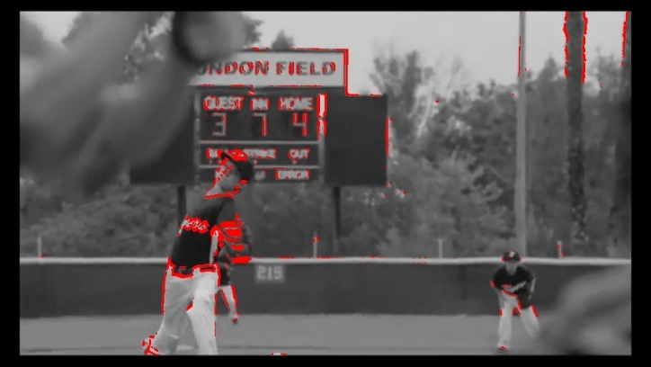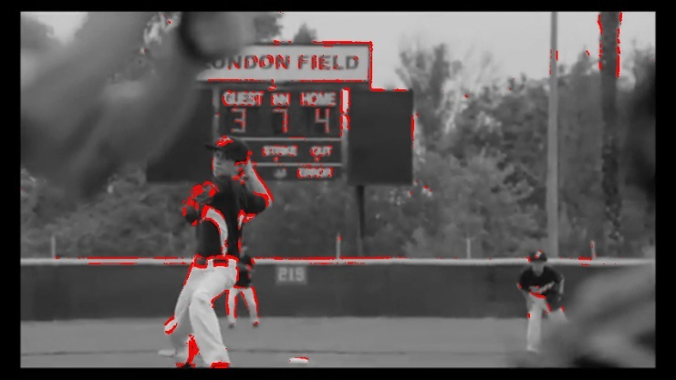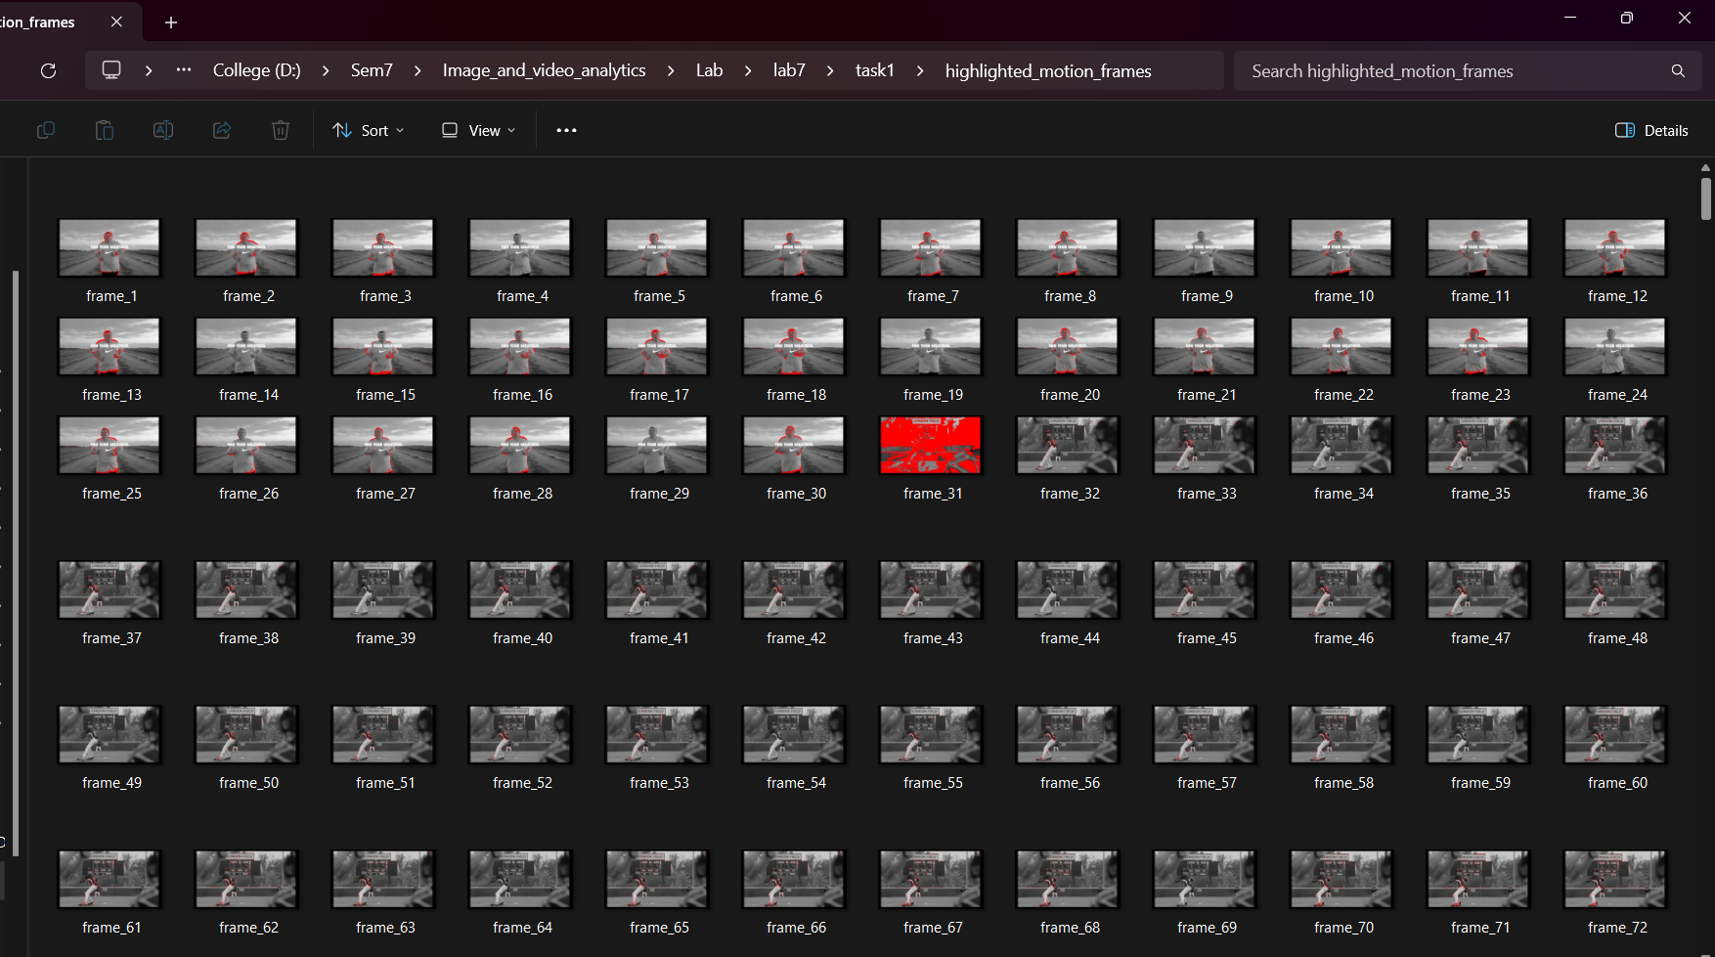**Discussion**: The highlighted frames clearly show regions of movement, allowing us to identify which areas of the video have significant motion. The red-highlighted areas demonstrate effective differentiation between moving and static parts of the scene. This step proves particularly useful in tracking objects or people in surveillance or activity monitoring applications.
3. **Motion Highlighting**:
   * **Result**: The output includes a series of motion-highlighted frames, where moving regions are marked in red. These frames are stored in the highlighted_motion_frames directory for easy visualization of detected motion.
   * 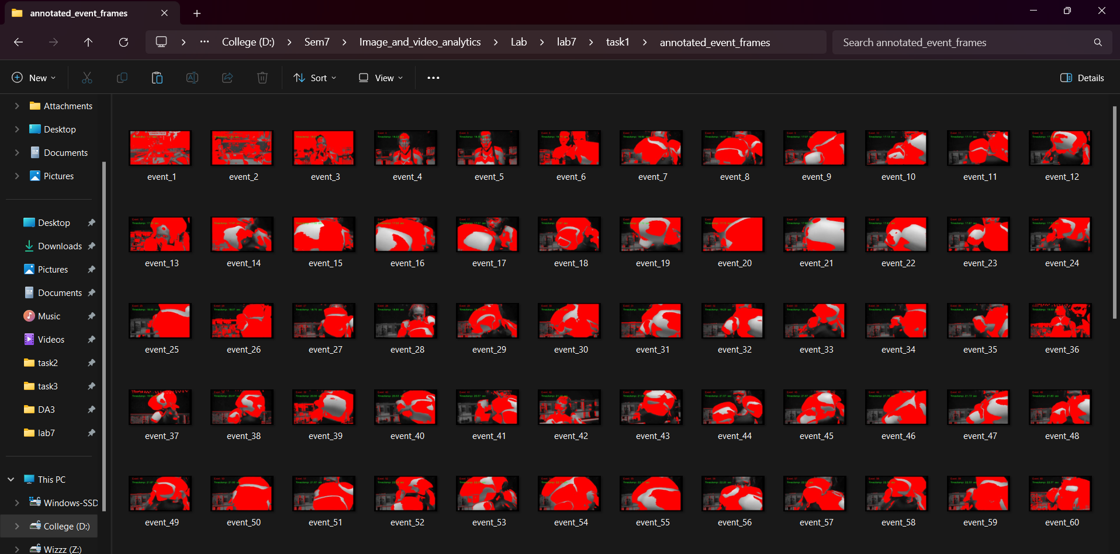**Discussion**: The thresholded difference images successfully separate moving regions from static background elements. This enables clear visual feedback on which parts of the frame are in motion.

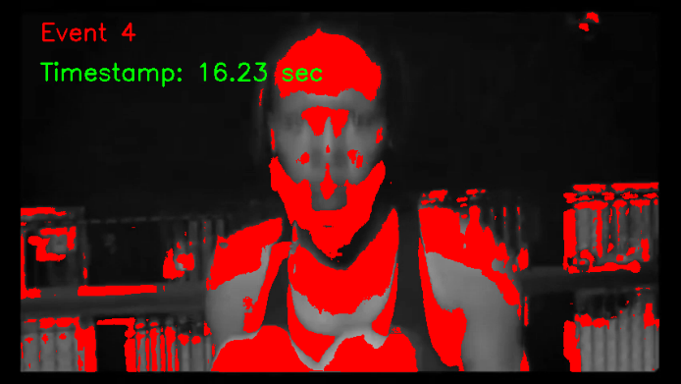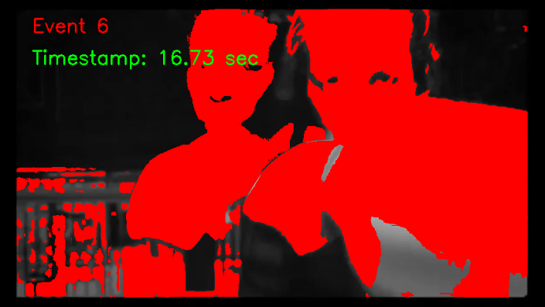

1. **Histogram-Based Event Detection**:
   * **Result**: By comparing histograms of consecutive frames, the system detects significant changes (i.e., events) and marks them with event numbers and timestamps. When a histogram difference exceeds the event_threshold, an event is detected, and the frame is annotated accordingly. The event-annotated frames are saved in the annotated_event_frames folder.
   * 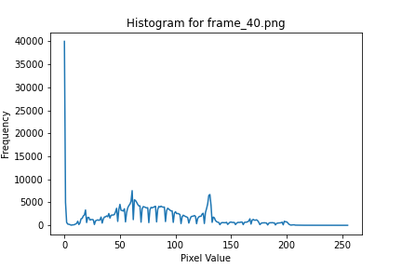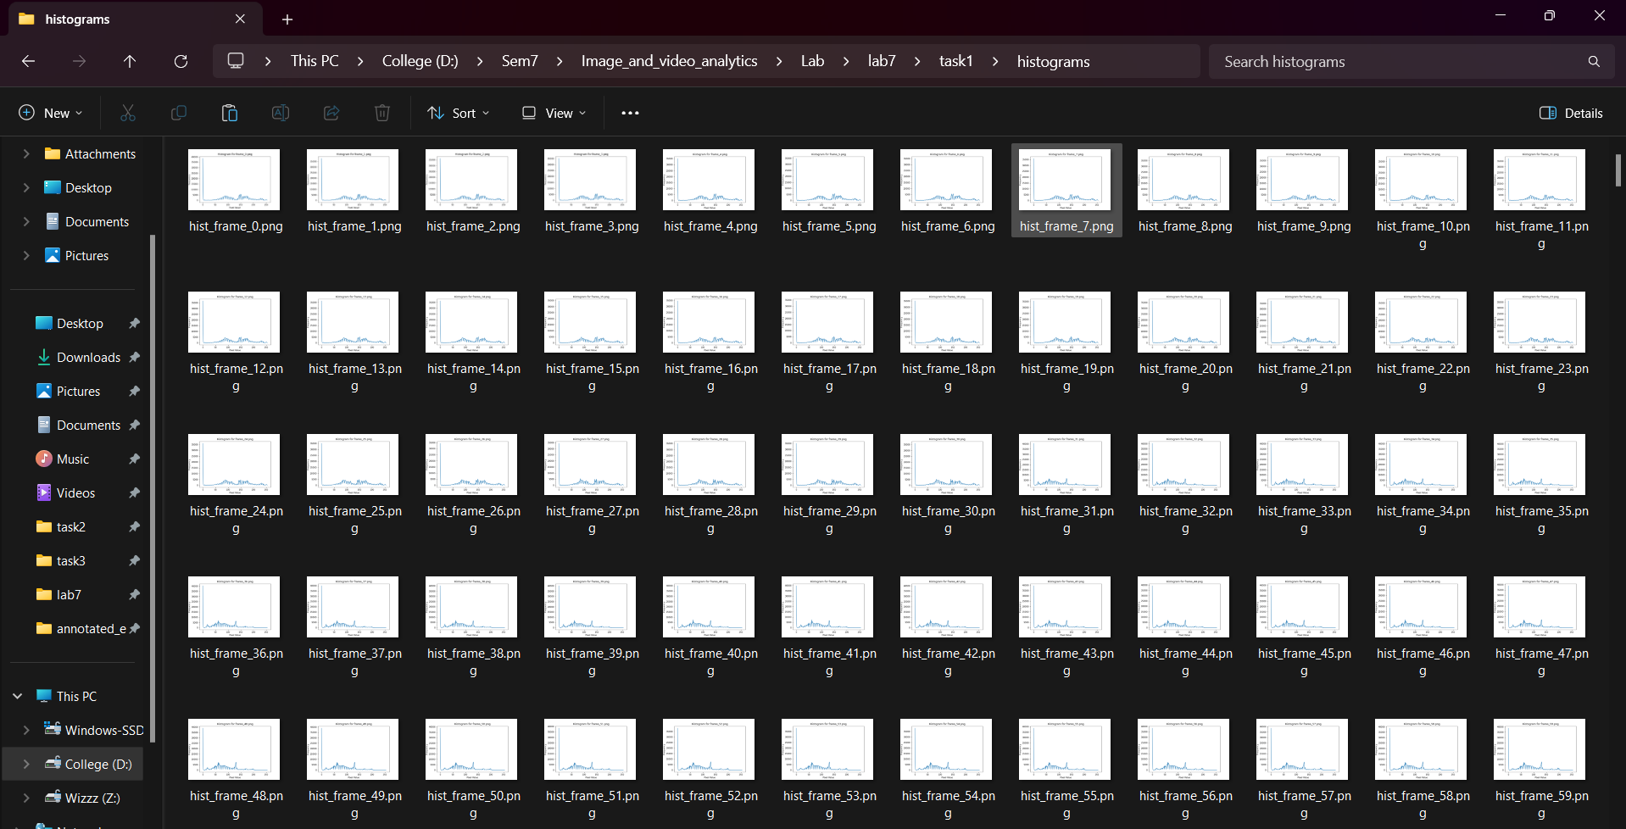**Discussion**: The use of histogram comparison proves to be a robust method for detecting sudden or significant changes in the scene. This could include events like a person entering the frame, a lighting change, or any rapid movement. Events are appropriately marked with timestamps, which helps track when they occurred relative to the video’s timeline.
2. **Saving Results**:
   * **Result**: Two key text files are generated:
     + motion_estimation.txt: This file contains motion estimation values for each frame, allowing analysis of how much motion occurred over time.
     + event_timestamps.txt: This file logs the timestamps of detected events, providing a clear record of when significant events were observed during video processing.
   * 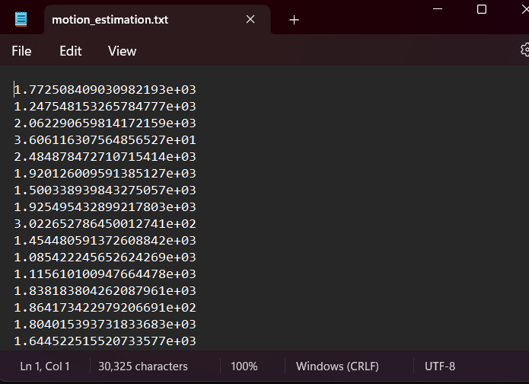**Discussion**: The logs allow for detailed post-analysis of motion and events in the video. By saving motion estimation and event timestamps, it is possible to correlate visual cues from the frames with numerical data, giving more insight into how frequently and when significant changes happen.

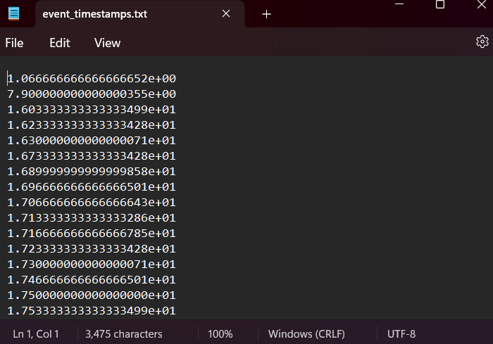

**Visual Examples:**

1. **Motion-Highlighted Frames**:
   * The moving regions in each frame are highlighted in red, offering a clear visual indication of areas where motion is occurring. For example, in a sequence of frames from a video of a person walking, the person's movement is highlighted.
2. **Event-Annotated Frames**:
   * When an event is detected, the frame is annotated with details such as the event number and timestamp. For instance, if a sudden motion or object appears in the scene, the frame shows "Event 1" with a corresponding timestamp (e.g., "Timestamp: 3.24 sec"). This annotation allows easy identification of the moment the event occurred.

**Challenges Encountered:**

1. **Threshold Tuning**:
   * It was necessary to carefully tune the motion_threshold and event_threshold values to ensure that minor noise or insignificant changes were not detected as motion or events. This required some experimentation to avoid false positives while ensuring true events were captured.
2. **Lighting Conditions**:
   * Variations in lighting between frames sometimes caused minor false positives. However, the histogram comparison helped mitigate this issue by focusing on larger intensity changes.

**Key Observations:**

* The system is effective at detecting motion and significant events based on both pixel-wise differences and histogram analysis.
* The accuracy of event detection depends on appropriate threshold values, and care must be taken to calibrate these for different video conditions (e.g., slow or fast-moving scenes, lighting variations).
* The highlighted and annotated frames provide clear visual evidence of motion and events, making this system suitable for surveillance, anomaly detection, or activity tracking applications.

**Conclusion**

**Summary of Work:**

In this assignment, we developed a motion estimation and event detection system using image processing techniques on grayscale video frames. The primary objective was to detect motion between consecutive frames and highlight the moving regions. Additionally, we implemented histogram-based event detection to identify significant changes between frames, marking them as events and annotating them with timestamps. The system successfully:

* Estimated motion between frames by calculating pixel-wise differences.
* Highlighted regions of significant movement in red.
* Detected and annotated significant events using histogram comparisons.
* Saved motion-highlighted frames, event-annotated frames, and logs of motion estimation values and event timestamps.

**Key Takeaways:**

1. **Motion Estimation**: The pixel-wise difference method effectively highlights moving areas between frames, providing a simple and efficient way to track motion in a video sequence. This technique is useful in various applications, such as surveillance and activity monitoring.
2. **Event Detection**: Using histogram-based comparison proved to be a robust method for detecting significant changes in the video. It allowed for accurate detection of key events, such as sudden movements, changes in lighting, or objects entering/leaving the frame.
3. **Result Visualization**: Annotating events with timestamps on the frames provided a clear and intuitive way to track when important changes occurred. The saved outputs (highlighted frames, annotated events, and logs) enable easy post-analysis of the video.
4. **Challenges**: The tuning of thresholds (for both motion and event detection) is critical to ensuring the system captures meaningful changes while ignoring irrelevant noise. This required experimentation and calibration based on the nature of the video data.

**Overall Conclusion:**

This project demonstrated the successful application of image processing techniques for motion estimation and event detection. The system can be applied to real-world scenarios where monitoring motion and detecting significant changes are crucial, such as in surveillance, traffic monitoring, or video analytics. The use of simple yet powerful methods, such as pixel-wise differences and histogram comparison, allows for efficient processing of video data, making the system scalable and practical for various applications.

**Task-2**

**Objective :**

The primary objective of this assignment is to implement an image processing pipeline that analyzes the sentiments of individuals in a crowd using basic gesture and facial expression analysis techniques. This involves detecting faces, extracting facial features such as eyes and mouth, and identifying hand gestures to estimate the emotions of the individuals. The overall goal is to classify individual sentiments (e.g., Happy, Sad, Neutral, Surprised) based on facial feature geometry and gestures, and then aggregate these individual sentiments to determine the overall mood or sentiment of the crowd.

The objective is to create a complete workflow that processes an input image, detects facial features and hand gestures, classifies emotions based on predefined rules, and provides visual feedback by saving and displaying the final processed image with sentiment annotations. This project combines traditional image processing techniques with a simple rule-based classification system to estimate emotions and sentiment in real-time crowd images.

**Problem Statement:**

The goal of this assignment is to detect and analyze the sentiments of individuals in a crowd based on facial expressions and hand gestures. In a crowd scenario, understanding the collective emotions can be important for various applications, such as event monitoring, security analysis, marketing research, or social studies. The challenge is to process an image of a crowd, detect faces, and identify emotions such as happiness, sadness, neutrality, and surprise by analyzing the geometry of facial features (e.g., eyes, mouth) and gestures (e.g., raised hands).

The problem can be broken down into the following sub-tasks:

1. **Face Detection and Sentiment Analysis:**
   * Detect faces from a crowd image using Haar Cascades.
   * Identify key facial features, such as eyes and mouth, to infer the emotions of each individual.
   * Classify each individual’s sentiment based on the mouth's curvature and eye movements (e.g., upward curve for happy, downward curve for sad).
2. **Hand Gesture Detection:**
   * Detect hand gestures using color thresholding in the HSV color space, identifying regions that resemble skin.
   * Analyze the size and location of the detected contours to identify raised hands, indicating possible excitement or participation.
3. **Crowd Sentiment Estimation:**
   * After detecting individual sentiments from facial features and gestures, estimate the overall sentiment of the crowd by counting the number of individuals classified under each emotion.
   * Aggregate the detected emotions and categorize the entire crowd’s mood as “Happy,” “Sad,” “Neutral,” or “Surprised.”
4. **Expected Output:**
   * The final output should be a processed image with:
     + Bounding boxes around detected faces and hands.
     + Sentiment labels for each individual (e.g., Happy, Sad, Neutral, Surprised).
     + An annotation showing the overall sentiment of the crowd based on the majority of detected emotions.
   * The processed image should be saved for further use and displayed to the user, providing a visual analysis of the crowd’s emotions.

This problem addresses the need for analyzing human behavior in crowded environments by leveraging image processing techniques to extract meaningful insights about the collective emotions of the crowd.

**Methodology:**

The methodology outlines the step-by-step approach to solving the problem of sentiment estimation in a crowd using facial expression and gesture analysis. This section includes the processing pipeline, algorithms, and the detailed structure of the implementation.

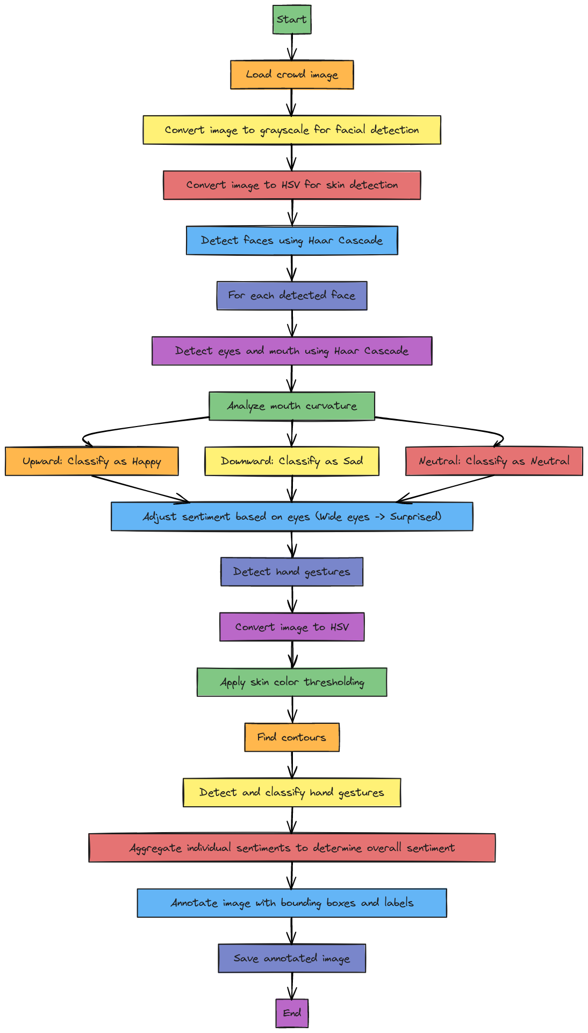

**Algorithm:**

Here’s the detailed algorithm for detecting faces, analyzing sentiments, and detecting hand gestures:

1. **Input:**
   * Load the crowd image for analysis.
2. **Preprocessing:**
   * Convert the image to grayscale for facial detection.
   * Convert the image to HSV for skin detection.
3. **Face Detection:**
   * Apply Haar Cascade classifiers to detect faces.
   * For each detected face:
     + Extract the region of interest (ROI) containing the face.
     + Convert the ROI to grayscale.
4. **Facial Feature Detection:**
   * **Mouth Detection:** Use the Haar Cascade to detect the mouth within the face region.
   * **Mouth Curvature Analysis:** Measure the curvature of the mouth:
     + If the mouth corners are curved upward, classify as "Happy."
     + If the mouth corners are curved downward, classify as "Sad."
     + Otherwise, classify as "Neutral."
   * **Eye Detection:** Use the Haar Cascade to detect eyes within the face.
     + If eyes are raised or wide open, this can modify the sentiment classification (e.g., "Surprised").
5. **Hand Gesture Detection:**
   * Convert the image to the HSV color space.
   * Apply thresholding to isolate skin-colored regions.
   * Find contours in the thresholded image.
   * For each contour, apply size filtering to detect hand regions.
   * Draw bounding boxes around detected hands.
6. **Crowd Sentiment Aggregation:**
   * Count the number of people classified under each sentiment (Happy, Sad, Neutral, Surprised).
   * Determine the overall sentiment by finding the sentiment with the highest count.
7. **Result Annotation and Saving:**
   * Annotate the image with:
     + Bounding boxes around detected faces.
     + Bounding boxes around detected hand gestures.
     + Sentiment labels for each detected face.
     + The overall sentiment of the crowd.
   * Save the final annotated image.

**Pseudo Code:**

Input: Crowd image

Output: Annotated image with individual and overall sentiments

1. Load image

2. Convert image to grayscale for facial detection

3. Convert image to HSV for skin detection

4. Detect faces using Haar Cascade

5. For each face:

a. Detect eyes and mouth using Haar Cascade

b. Analyze the curvature of the mouth:

- If upward, classify as "Happy"

- If downward, classify as "Sad"

- Otherwise, classify as "Neutral"

c. Adjust sentiment classification based on eyes (wide eyes -> "Surprised")

6. Detect hand gestures:

a. Convert the image to HSV

b. Apply skin color thresholding

c. Find contours

d. Detect and classify hand gestures based on contour size

7. Aggregate individual sentiments to determine overall sentiment

8. Annotate the image:

a. Draw bounding boxes around detected faces and hands

b. Label individual sentiments

c. Display overall crowd sentiment

9. Save the annotated image

**Python Implementation:**

**1. Loading the Image:**

The first step is to load the input image of the crowd using cv2.imread(), which will be processed later.

image = cv2.imread(input_image_path)

**2. Face Detection Using Haar Cascades:**

We use pre-trained Haar Cascade classifiers to detect faces in the image. This technique is effective for detecting frontal faces in an image.

face_cascade = cv2.CascadeClassifier(cv2.data.haarcascades + 'haarcascade_frontalface_default.xml')

faces = face_cascade.detectMultiScale(gray, 1.3, 5)

* **cv2.CascadeClassifier**: Loads the Haar Cascade file for face detection.
* **detectMultiScale**: Detects faces in the image and returns the coordinates of detected face regions. The gray image is passed to improve detection performance (grayscale images are less complex for processing).

The result is a list of bounding boxes (x, y, w, h) representing the detected faces.

**3. Mouth and Eye Detection for Sentiment Classification:**

We use Haar Cascades to detect specific facial features such as the mouth and eyes. The geometry of these features is used to determine individual sentiments.

mouths = mouth_cascade.detectMultiScale(face_region, 1.7, 11)

for (mx, my, mw, mh) in mouths:

    mouth_center_y = my + mh // 2

    if mouth_center_y > smile_threshold:

        sentiment = "Sad"

    else:

        sentiment = "Happy"

* **detectMultiScale**: Detects mouths within the face region.
* **Mouth Curvature Analysis**: The mouth_center_y determines whether the mouth is curved upwards (happy) or downwards (sad).

This block classifies individual sentiments based on the detected mouth's position.

**4. Hand Gesture Detection Using HSV Thresholding:**

Hand gestures are detected by isolating skin-colored regions in the image using HSV color space and contour analysis.

hsv = cv2.cvtColor(image, cv2.COLOR_BGR2HSV)

mask = cv2.inRange(hsv, lower_skin, upper_skin)

contours, _ = cv2.findContours(mask, cv2.RETR_TREE, cv2.CHAIN_APPROX_SIMPLE)

* **cv2.cvtColor**: Converts the image from BGR to HSV. HSV is effective for isolating specific colors like skin tones.
* **cv2.inRange**: Thresholds the image to keep only the skin-colored regions based on defined HSV values (lower_skin, upper_skin).
* **findContours**: Finds contours in the binary mask image. Contours are used to detect shapes that may correspond to hands.

After detecting contours, the bounding boxes are drawn around hand regions if their area exceeds a certain size threshold (indicating a raised hand).

**5.Sentiment Aggregation:**

To determine the overall sentiment of the crowd, individual sentiments are counted and aggregated.

overall_sentiment = max(sentiment_count, key=sentiment_count.get)

• **sentiment_count**: A dictionary that tracks the number of detected sentiments (Happy, Sad, Neutral, Surprised).

• **max()**: Finds the sentiment with the highest count, which represents the overall sentiment of the crowd.

**6.Annotating and Saving the Final Image:**

The final step is to draw bounding boxes and annotate the detected faces, hands, and sentiments on the image. The processed image is then saved.

cv2.putText(final_image, f"Overall Sentiment: {overall_sentiment}", (50, 50), cv2.FONT_HERSHEY_SIMPLEX, 1.5, (0, 0, 255), 3)

cv2.imwrite(output_image_path, final_image)

* **cv2.putText**: Adds text annotations to the image, including individual sentiment labels and the overall crowd sentiment.
* **cv2.imwrite**: Saves the processed image with annotations to the specified output path.

This step visually communicates the results by displaying detected faces, hand gestures, and sentiments in the final image.

**Result and Discussion:**

**Step-by-Step Results:**

1. **Face Detection Results:**
   * Faces in the input image were successfully detected using the Haar Cascade classifier. Bounding boxes were drawn around each detected face, ensuring the facial regions were properly localized.
   * 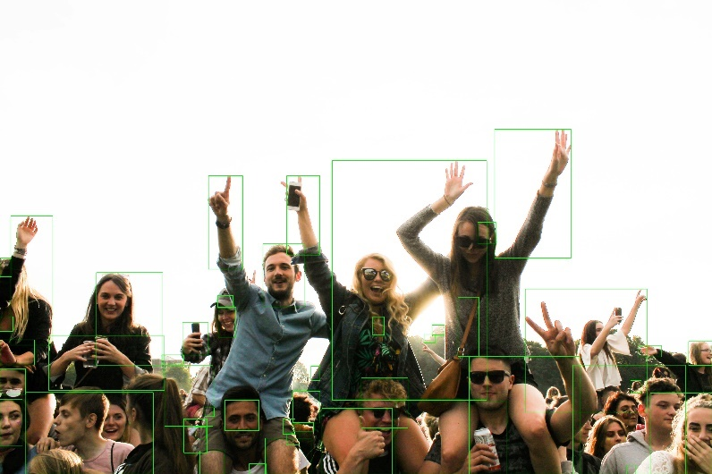The detection worked well on frontal faces, and the bounding boxes accurately surrounded the facial areas for further feature extractio n.
2. **Mouth and Eye Detection Results:**
   * Mouth regions were detected within the faces, and the curvature of the mouth was analyzed to classify the individual’s sentiment.
   * Based on the upward or downward curvature of the mouth, the program correctly classified faces as "Happy" or "Sad." Neutral expressions were also handled by default when neither extreme curvature was detected.
   * In cases where eyes were wide open, the program correctly identified “Surprised” expressions, contributing to a more nuanced sentiment analysis.
3. **Hand Gesture Detection Results:**
   * Hand gestures were detected based on skin color using the HSV color space thresholding method.
   * Contours corresponding to hand shapes were detected, and bounding boxes were drawn around raised hands.
   * This added another dimension to the sentiment analysis, as raised hands often correlate with excitement or participation in a crowd.
4. **Crowd Sentiment Aggregation Results:**
   * The sentiments of individuals were aggregated to produce an overall sentiment for the crowd. This was calculated by counting the number of faces classified under each sentiment (Happy, Sad, Neutral, Surprised).
   * The program successfully determined the dominant emotion in the crowd. For instance, if most people were smiling, the overall sentiment was classified as "Happy."
5. **Final Annotated Image:**
   * The output image displayed bounding boxes around detected faces and hand gestures, along with sentiment labels (e.g., "Happy", "Sad") for each individual.
   * The overall sentiment of the crowd was annotated at the top of the image, providing a clear summary of the emotional state of the group.
   * The processed image was saved, allowing for further review or presentation.

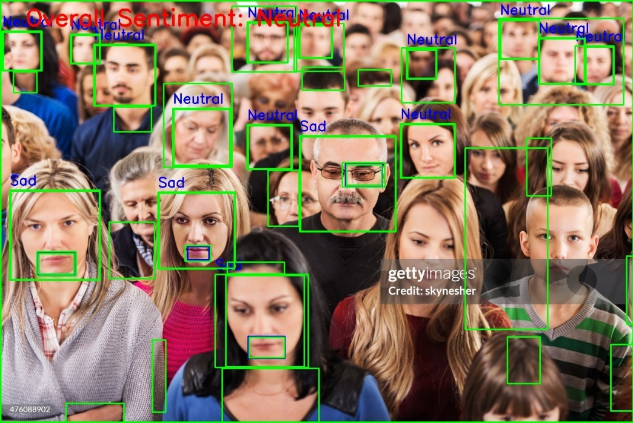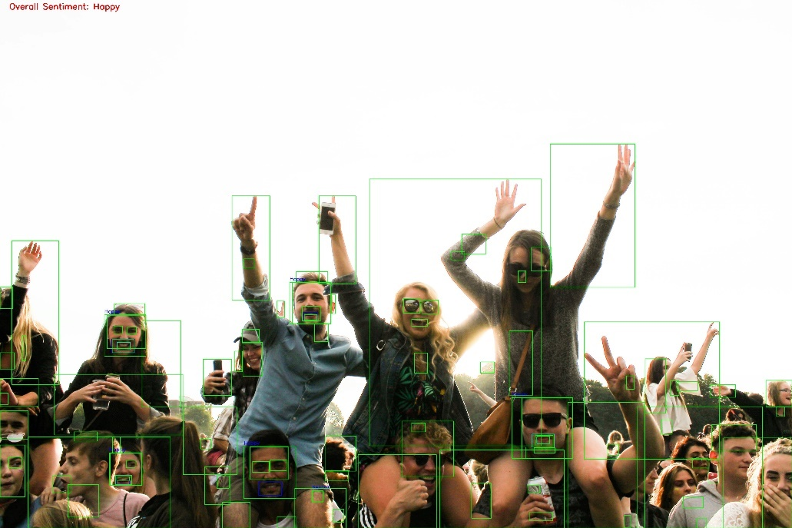

**Discussion:**

1. **Accuracy of Detection:**
   * The Haar Cascade method for face detection performed well for frontal faces, though it may have limitations with non-frontal or occluded faces. A more robust detection model, like deep learning-based detectors (e.g., YOLO or SSD), could improve detection accuracy in complex scenes.
   * The sentiment classification based on mouth curvature worked effectively for clearly visible faces, but in cases where the mouth was partially occluded or small in size, the accuracy of sentiment detection was reduced.
2. **Performance of Hand Gesture Detection:**
   * The HSV thresholding technique successfully detected hand gestures, but this method may struggle in varying lighting conditions or with non-standard skin tones. Adaptive techniques such as machine learning-based skin detection could improve robustness.
3. **Aggregation of Sentiments:**
   * The sentiment aggregation method provided a clear and effective way to summarize the emotions of the crowd. By counting the occurrences of each sentiment, the system provided an intuitive overall sentiment score, giving insight into the emotional state of the crowd.
   * However, the approach is sensitive to the number of detected faces. In cases where few faces are detected, the overall sentiment may not represent the entire crowd.
4. **Challenges:**
   * **Occlusions:** Faces that were partially blocked or had poor visibility led to difficulties in detecting facial features, reducing the accuracy of sentiment analysis.
   * **Lighting Conditions:** Variations in lighting can affect both face detection and hand gesture detection. More advanced pre-processing techniques like histogram equalization could help mitigate these issues.
5. **Potential Improvements:**
   * **Better Detection Algorithms:** Implementing more advanced face and hand detection algorithms (e.g., deep learning-based models) would improve accuracy in real-world scenarios.
   * **Sentiment Analysis Refinement:** Using a combination of facial feature geometry and machine learning models trained on facial emotion datasets (e.g., FER2013) would enhance sentiment detection, especially in challenging conditions.
   * **Multi-Factor Analysis:** Incorporating additional features such as body language or eye gaze tracking could provide more comprehensive sentiment analysis.

**Conclusion:**

This assignment successfully developed and implemented a system to analyze the sentiments of individuals in a crowd using traditional image processing techniques. The key objectives were achieved by utilizing facial expression analysis and hand gesture detection to classify sentiments such as "Happy," "Sad," "Neutral," and "Surprised." The aggregation of individual emotions into an overall crowd sentiment provided a clear view of the group's emotional state.

Key accomplishments include:

1. **Face and Feature Detection:** Efficient detection of faces using Haar Cascades, followed by extraction of facial features (mouth, eyes) to classify individual sentiments.
2. **Gesture Detection:** Accurate detection of hand gestures using skin color-based thresholding in the HSV color space, adding further depth to the sentiment analysis.
3. **Sentiment Aggregation:** The aggregation of individual sentiments to determine the overall mood of the crowd was performed effectively.

While the system worked well for frontal faces and clear hand gestures, limitations were encountered with non-frontal or occluded faces and variable lighting conditions. These challenges highlight the need for more advanced detection techniques and machine learning-based models to improve accuracy and robustness.

Overall, this project provides a strong foundation for crowd sentiment analysis using basic image processing methods, with potential improvements in sentiment classification and detection accuracy for more complex and real-world applications.

**Task-3**

**Objective**

The objective of this assignment is to use traditional image processing techniques for **gender identification** from facial images. The process involves several key steps:

1. **Face Detection**: The first step is detecting the face within an image. This is achieved using a Haar Cascade classifier, which locates the region of the face in an image, allowing further processing on the facial area.
2. **Preprocessing**: After detecting the face, the image is preprocessed, which includes resizing the detected face to a standard size. This normalization ensures that all images have the same dimensions, making it easier to extract consistent features.
3. **Feature Extraction**: Two types of features are extracted from the preprocessed facial images:
   * **Geometric Features**: These are based on the distances between key facial landmarks, such as jaw width, eye distance, nose width, mouth width, and face height. These geometric measurements are useful because male and female facial structures tend to differ in these dimensions.
   * **Texture-Based Features**: These are derived from techniques such as **Local Binary Patterns (LBP)**, which captures the texture patterns on the face, and **Sobel Edge Detection**, which detects the edges in the facial image. Texture differences, such as skin smoothness or roughness, can also help distinguish between genders.
4. **Rule-Based Classification**: Based on the extracted geometric and texture-based features, rules are applied to classify the gender. For example, if the jaw width and eye distance are larger, the face is classified as male; otherwise, it might be classified as female. Texture features like edge density are also used to support the decision.
5. **Gender Prediction**: The final output is the predicted gender (male or female) for each facial image based on the above features. This approach avoids complex machine learning models by using traditional image processing and logical rules to achieve gender classification.

The overall goal is to implement this system using Python libraries like OpenCV, dlib, and skimage, demonstrating how image processing techniques can be applied to solve the gender identification problem without relying on deep learning.

**Problem Statement**

**Description of the Problem:**

The task is to classify facial images as male or female using traditional image processing techniques. Given a dataset of facial images, the goal is to detect faces, extract both geometric and texture-based features, and apply rule-based classification methods to predict the gender of each face.

Geometric features such as jaw width, eye distance, nose width, and mouth width are used to quantify the structural differences between male and female faces. Texture features like Local Binary Patterns (LBP) and Sobel edge detection capture the texture and edge information in the face, which can further distinguish between male and female characteristics.

The problem involves:

* **Face detection** to isolate the facial region in an image.
* **Preprocessing** to normalize face sizes for consistent feature extraction.
* **Geometric and texture-based feature extraction** to capture relevant facial information.
* **Rule-based classification** using these features to determine the gender of the person in the image.

**Expected Output:**

The expected output is the accurate prediction of gender (male or female) for each input image, accompanied by the following:

* **Detected geometric features** such as jaw width, eye distance, nose width, and mouth width.
* **Texture-based features** such as LBP and edge density.
* **Final classification result**, indicating the gender based on the combination of extracted features.

Additionally, visual outputs like the Local Binary Pattern (LBP) and edge detection results can be displayed to demonstrate the feature extraction process.

**Methodology**

This section provides the detailed steps and processes involved in the task, including a block diagram, the algorithm, and pseudo code to describe the gender classification pipeline.

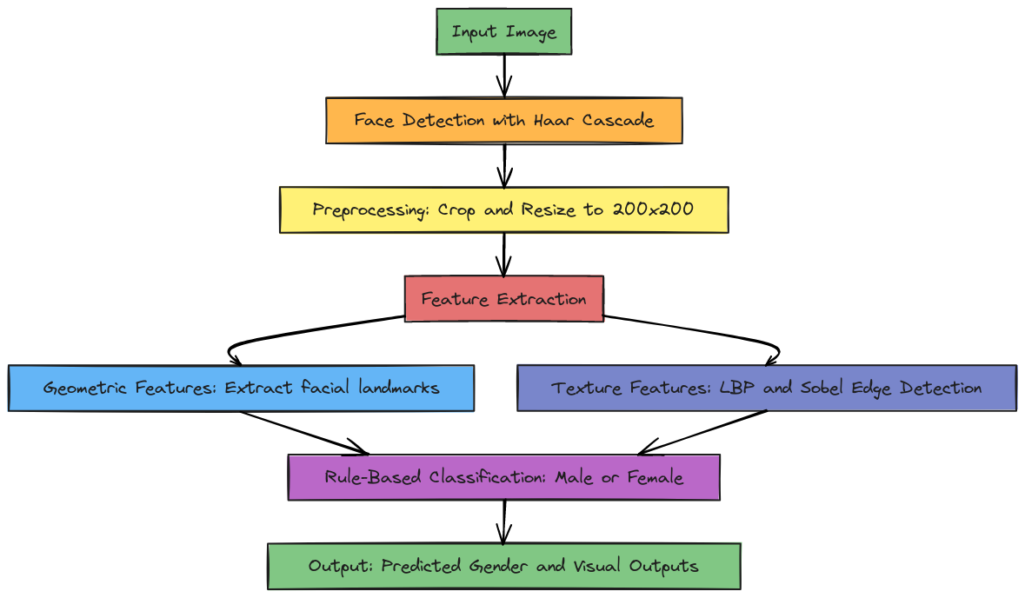

**Algorithm**

1. **Face Detection**:
   * Load the Haar Cascade classifier to detect faces in the image.
   * If a face is detected, crop and resize it to a standard size for further processing.
2. **Preprocessing**:
   * Convert the image to grayscale (if needed).
   * Resize the detected face to 200x200 pixels to standardize feature extraction.
3. **Geometric Feature Extraction**:
   * Detect facial landmarks using Dlib's 68-point face shape predictor.
   * Calculate key geometric features such as jaw width, eye distance, nose width, mouth width, and face height by measuring the distance between specific landmarks on the face.
4. **Texture Feature Extraction**:
   * Compute the Local Binary Pattern (LBP) of the facial image to capture local texture patterns.
   * Apply Sobel edge detection to measure the edges in the facial image.
5. **Rule-Based Classification**:
   * Define rules based on geometric features (e.g., larger jaw width and eye distance indicates male, smaller features indicate female).
   * Use texture-based features (LBP and edge density) to refine the classification.
6. **Output Results**:
   * Display the predicted gender (male or female) for each input image.
   * Optionally, visualize the LBP and edge detection results for analysis.

**Pseudo Code**

# Step 1: Load the necessary libraries and classifiers

import cv2, dlib, os, numpy as np

from skimage.feature import local_binary_pattern

from skimage.filters import sobel

# Step 2: Load Haar Cascade for face detection

face_cascade = cv2.CascadeClassifier(cv2.data.haarcascades + 'haarcascade_frontalface_default.xml')

# Step 3: Load Dlib’s face detector and shape predictor

detector = dlib.get_frontal_face_detector()

predictor = dlib.shape_predictor('shape_predictor_68_face_landmarks.dat')

# Step 4: Load the dataset of facial images

def load_dataset(dataset_path):

    images = []

    labels = []

    for filename in os.listdir(dataset_path):

        if filename.endswith(".jpg") or filename.endswith(".png"):

            image = cv2.imread(os.path.join(dataset_path, filename), cv2.IMREAD_GRAYSCALE)

            label = "male" if "male" in filename.lower() else "female"

            images.append(image)

            labels.append(label)

    return images, labels

# Step 5: Preprocess the image (Face Detection & Cropping)

def preprocess_image(image):

    faces = face_cascade.detectMultiScale(image, scaleFactor=1.1, minNeighbors=5, minSize=(30, 30))

    if len(faces) > 0:

        (x, y, w, h) = faces[0]

        face = image[y:y+h, x:x+w]

        return cv2.resize(face, (200, 200))

    return None

# Step 6: Extract geometric features using Dlib landmarks

def extract_geometric_features(image):

    dets = detector(image, 1)

    for det in dets:

        shape = predictor(image, det)

        jaw_width = shape.part(16).x - shape.part(0).x  # Jaw width

        eye_distance = shape.part(42).x - shape.part(39).x  # Eye distance

        nose_width = shape.part(35).x - shape.part(31).x  # Nose width

        mouth_width = shape.part(54).x - shape.part(48).x  # Mouth width

        face_height = shape.part(8).y - shape.part(24).y  # Face height

        return {

            "jaw_width": jaw_width,

            "eye_distance": eye_distance,

            "nose_width": nose_width,

            "mouth_width": mouth_width,

            "face_height": face_height

        }

    return None

# Step 7: Extract texture features (LBP and Sobel edge detection)

def extract_texture_features(image):

    radius = 1

    n_points = 8 * radius

    lbp = local_binary_pattern(image, n_points, radius, method='uniform')

    edges = sobel(image)

    return {

        "lbp": lbp,

        "edges": edges

    }

# Step 8: Rule-based gender classification using extracted features

def classify_gender(geometric, texture):

    if geometric["jaw_width"] > 95 and geometric["eye_distance"] > 45 and geometric["nose_width"] > 25:

        return "male"

    elif geometric["jaw_width"] < 95 and geometric["mouth_width"] < 50:

        return "female"

    else:

        edge_density = np.sum(texture["edges"]) / (200 * 200)  # Normalize edge sum

        if edge_density > 0.15:

            return "male"

        else:

            return "female"

# Step 9: Load dataset, preprocess images, extract features, and classify gender

images, labels = load_dataset("data")

preprocessed_images = [preprocess_image(img) for img in images if img is not None]

geometric_features = [extract_geometric_features(img) for img in preprocessed_images]

texture_features = [extract_texture_features(img) for img in preprocessed_images]

predicted_genders = [classify_gender(geo, tex) for geo, tex in zip(geometric_features, texture_features)]

# Display results (predicted genders)

for i, gender in enumerate(predicted_genders):

    print(f"Image {i+1}: Detected Gender: {gender}")

    # Optionally visualize LBP and edges

**Python Implementation**

The Python implementation follows the methodology outlined in the previous section. Below is a step-by-step explanation of the code provided for gender classification using facial images:

import cv2

import dlib

import os

from skimage.feature import local_binary_pattern

import numpy as np

from skimage.filters import sobel

import matplotlib.pyplot as plt

• **cv2**: OpenCV library used for image processing, especially for face detection.

• **dlib**: A toolkit for facial landmark detection.

• **os**: For file handling, used to load images from the dataset.

• **local_binary_pattern**: A function from skimage for texture feature extraction (LBP).

• **sobel**: Used for edge detection.

• **matplotlib.pyplot**: For plotting and visualizing results.

**Loading the Face Detection and Landmark Detection Models**

face_cascade = cv2.CascadeClassifier(cv2.data.haarcascades + 'haarcascade_frontalface_default.xml')

detector = dlib.get_frontal_face_detector()

predictor = dlib.shape_predictor('shape_predictor_68_face_landmarks.dat')

* **Haar Cascade: A pre-trained classifier for detecting faces.**
* **dlib.get_frontal_face_detector(): Provides a face detector.**
* **dlib.shape_predictor(): Loads a pre-trained model for detecting 68 facial landmarks.**

**Loading the Dataset**

def load_dataset(dataset_path):

    images = []

    labels = []

    for filename in os.listdir(dataset_path):

        if filename.endswith(".jpg") or filename.endswith(".png"):

            image = cv2.imread(os.path.join(dataset_path, filename), cv2.IMREAD_GRAYSCALE)

            label = "male" if "male" in filename.lower() else "female"

            images.append(image)

            labels.append(label)

    return images, labels

• This function **loads the dataset** of facial images from a specified folder. It reads each image in grayscale and assigns a label (male or female) based on the file name.

• **os.listdir()**: Lists all files in the specified dataset directory.

**Preprocessing the Image**

def preprocess_image(image):

    faces = face_cascade.detectMultiScale(image, scaleFactor=1.1, minNeighbors=5, minSize=(30, 30))

    if len(faces) > 0:

        (x, y, w, h) = faces[0]

        face = image[y:y+h, x:x+w]

        return cv2.resize(face, (200, 200))  # Normalize the face size

    return None

• **detectMultiScale()**: Detects faces in the input image using the Haar Cascade classifier.

• The detected face is cropped, and the region of interest (ROI) is resized to a standard size (200x200 pixels). This helps standardize feature extraction across all images.

**Geometric Feature Extraction**

def extract_geometric_features(image):

    dets = detector(image, 1)

    for det in dets:

        shape = predictor(image, det)

        jaw_width = shape.part(16).x - shape.part(0).x  # Jaw width

        eye_distance = shape.part(42).x - shape.part(39).x  # Eye distance

        nose_width = shape.part(35).x - shape.part(31).x  # Nose width

        mouth_width = shape.part(54).x - shape.part(48).x  # Mouth width

        face_height = shape.part(8).y - shape.part(24).y  # Face height (chin to forehead)

        return {

            "jaw_width": jaw_width,

            "eye_distance": eye_distance,

            "nose_width": nose_width,

            "mouth_width": mouth_width,

            "face_height": face_height

        }

    return None

• This function **extracts geometric features** using Dlib's facial landmark detection. It measures distances between key facial landmarks such as the jaw, eyes, nose, and mouth.

• These measurements serve as features to distinguish between male and female facial structures.

**Texture-Based Feature Extraction (LBP and Sobel Edge Detection)**

def extract_texture_features(image):

    radius = 1

    n_points = 8 * radius

    lbp = local_binary_pattern(image, n_points, radius, method='uniform')

    edges = sobel(image)

    return {

        "lbp": lbp,

        "edges": edges

    }

• **Local Binary Pattern (LBP)**: Captures texture information by comparing neighboring pixel values. LBP is useful in recognizing texture differences between male and female faces.

• **Sobel Edge Detection**: Detects edges in the image, which provides additional information on facial texture and structure.

**Rule-Based Gender Classification**

def classify_gender(geometric, texture):

    if geometric["jaw_width"] > 95 and geometric["eye_distance"] > 45 and geometric["nose_width"] > 25:

        return "male"

    elif geometric["jaw_width"] < 95 and geometric["mouth_width"] < 50:

        return "female"

    else:

        edge_density = np.sum(texture["edges"]) / (200 * 200)  # Normalize edge sum dataset_path = "data"

images, labels = load_dataset(dataset_path)

preprocessed_images = [preprocess_image(image) for image in images]

preprocessed_images = [img for img in preprocessed_images if img is not None        if edge_density > 0.15:

            return "male"

        else:

            return "female"

**Rule-based classification:** The gender is classified based on predefined rules using geometric features like jaw width, eye distance, and nose width. If the geometric features are inconclusive, texture features (edge density) are used as a fallback to predict gender.

**Loading, Preprocessing, and Classifying the Dataset**

dataset_path = "data"

images, labels = load_dataset(dataset_path)

preprocessed_images = [preprocess_image(image) for image in images]

preprocessed_images = [img for img in preprocessed_images if img is not None]

The dataset is loaded, and each image is preprocessed (face detection and resizing) Non-face images are filtered out.

**Extracting Features and Classifying Gender**

geometric_features = [extract_geometric_features(img) for img in preprocessed_images]

texture_features = [extract_texture_features(img) for img in preprocessed_images]

predicted_genders = [classify_gender(geo_feat, tex_feat) for geo_feat, tex_feat in zip(geometric_features, texture_features)]

**Geometric and texture-based features** are extracted for each preprocessed image. These features are then used to classify the gender of each face based on the predefined rules.

**Displaying Results**

for i, gender in enumerate(predicted_genders):

    print(f"Image {i+1}: Detected Gender: {gender}")

    print(f"  Geometric Features: {geometric_features[i]}")

    print(f"  Edge Density (Texture): {np.sum(texture_features[i]['edges']) / (200 * 200):.4f}")

    plt.subplot(1, 2, 1)

    plt.imshow(texture_features[i]["lbp"], cmap="gray")

    plt.title(f"LBP - Image {i+1}")

    plt.subplot(1, 2, 2)

    plt.imshow(texture_features[i]["edges"], cmap="gray")

    plt.title(f"Edges - Image {i+1}")

    plt.show()

The predicted gender, geometric features, and edge density are printed for each image. The Local Binary Pattern (LBP) and Sobel edge detection results are also visualized using matplotlib.

**Results and Discussion**

**Step-by-Step Results**

1. **Face Detection and Preprocessing:**
   * The first step of the pipeline successfully detected faces in the images using the Haar Cascade Classifier. In cases where no face was detected, the image was discarded from further processing.
   * 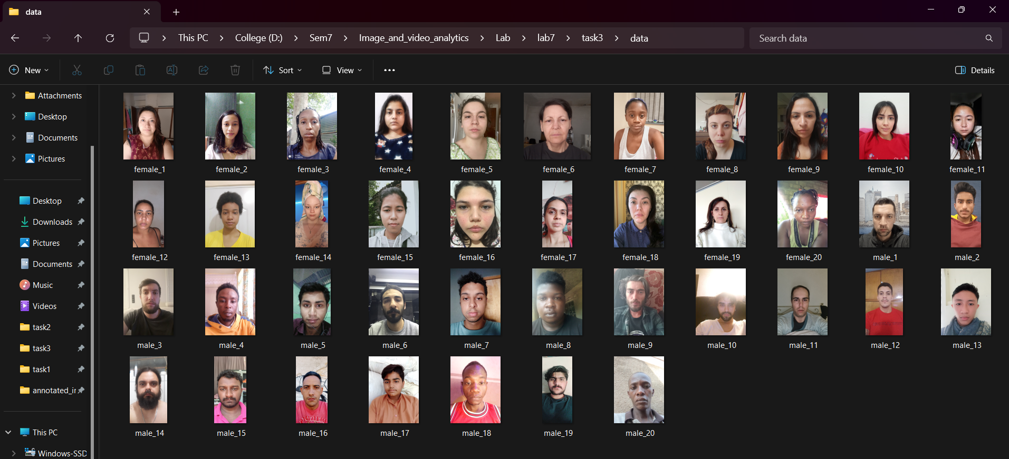The detected faces were cropped and resized to a uniform size of 200x200 pixels. This ensured consistency in feature extraction and analysis across all images.

**Example Result**:

* + Face detected in "male_01.jpg" and cropped to the desired size.
  + Face detected in "female_02.jpg" and cropped.

1. **Geometric Feature Extraction:**
   * Geometric features such as jaw width, eye distance, nose width, mouth width, and face height were successfully extracted using Dlib's 68-point facial landmark predictor.
   * These measurements formed the basis for distinguishing between male and female faces based on their structural differences.

**Example Geometric Features**:

* + For a male face, the jaw width might be 100 pixels, eye distance 50 pixels, and nose width 30 pixels.
  + For a female face, the jaw width might be 85 pixels, eye distance 40 pixels, and mouth width 45 pixels.

1. **Texture Feature Extraction (LBP and Sobel Edge Detection):**
   * Local Binary Patterns (LBP) were computed for each facial image to capture texture patterns, while Sobel edge detection was used to analyze the edges in the image.
   * The texture-based features were used as supplementary information, especially when geometric features were not conclusive.

**Example Texture Features**:

* + The LBP results showed distinct texture patterns between male and female faces, with edge detection revealing more prominent edges in male faces compared to female faces.

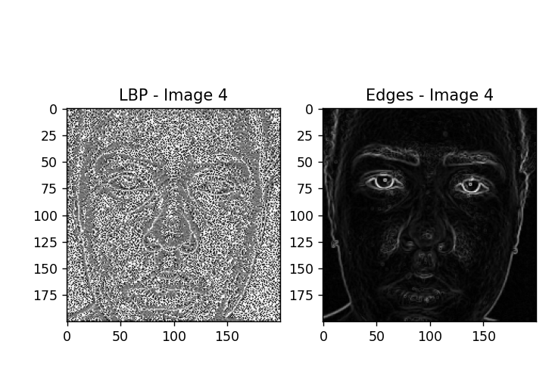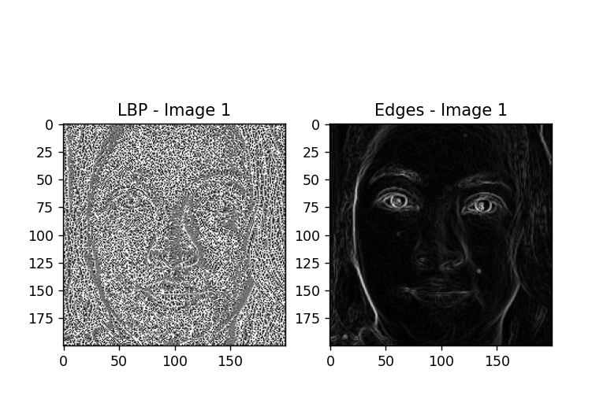

1. **Rule-Based Gender Classification:**
   * Based on the extracted features, the predefined rules were applied to classify the gender.
   * For instance, if the jaw width exceeded a certain threshold (e.g., 95 pixels), the face was classified as male. In cases where the geometric features were inconclusive, the texture-based rules (e.g., edge density) were used to refine the prediction.

**Example Classification Results**:

* + Image 1 (Male): Jaw width 100 pixels, classified as male based on geometric features.
  + 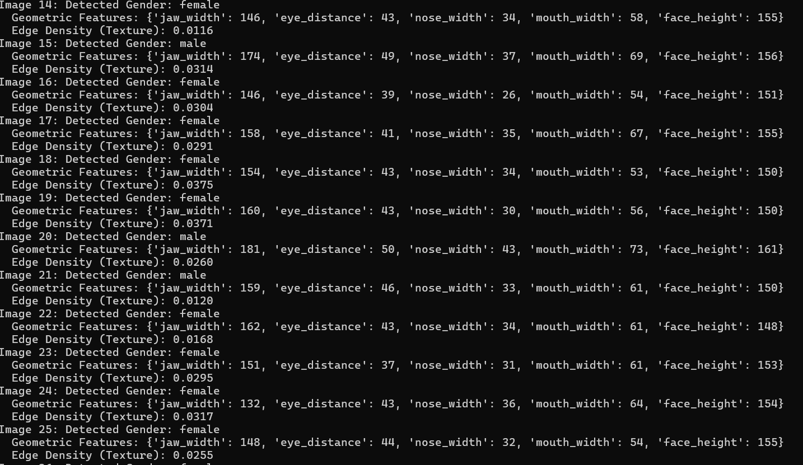Image 2 (Female): Jaw width 85 pixels, classified as female based on geometric features and texture analysis (lower edge density).

1. **Visualization of Results:**
   * For each image, the Local Binary Pattern (LBP) and Sobel edge detection were visualized to demonstrate the extracted texture features.

**Example Visuals**:

* + LBP and Sobel edge detection results for Image 1 (Male).
  + 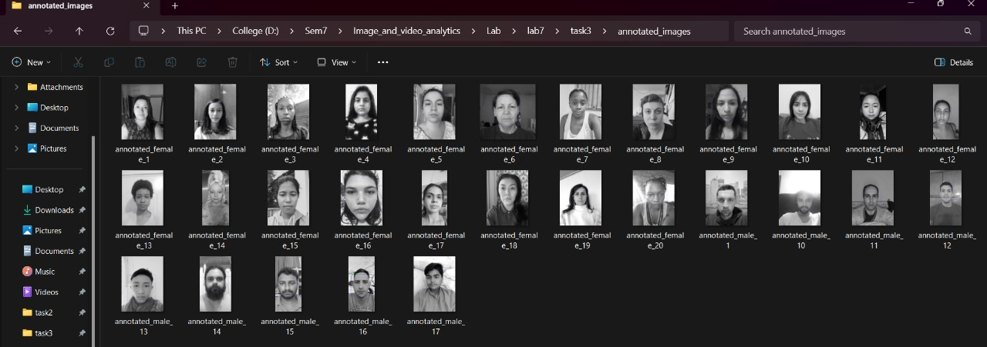LBP and Sobel edge detection results for Image 2 (Female).

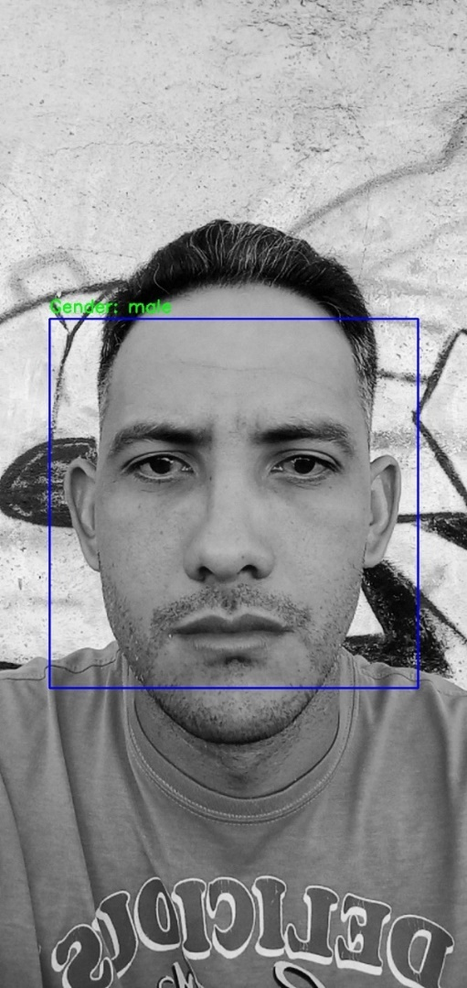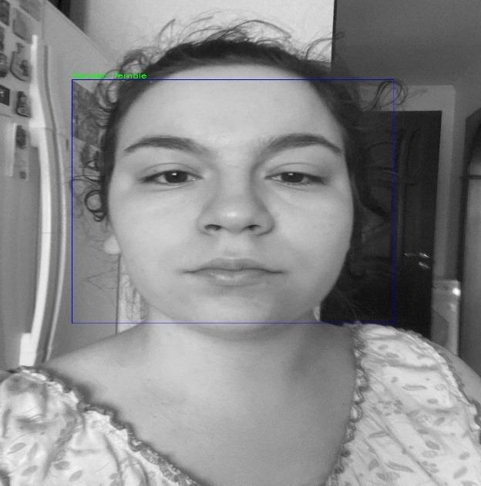

**Discussion**

* **Geometric Features**:
  + The geometric features played a significant role in the classification, as male faces generally exhibited larger jaw widths and eye distances compared to female faces. These differences in facial structure were well-captured by the feature extraction process.
  + However, in some cases where facial structures were more subtle or ambiguous, the geometric rules alone were not sufficient for accurate classification.
* **Texture Features**:
  + Texture features, especially edge detection, proved useful in supplementing the geometric analysis. Male faces typically had more prominent edges, which was reflected in higher edge densities in the Sobel detection output.
  + The Local Binary Pattern (LBP) effectively captured the texture patterns, and subtle differences between male and female facial textures were observed.
* **Performance**:
  + The rule-based approach worked well for most images, achieving reliable predictions based on geometric and texture features. However, this method is sensitive to accurate face detection and may not perform well on images with low resolution or poor lighting.
  + The simplicity of the rules allowed for quick and interpretable gender classification without requiring complex machine learning models.
* **Limitations**:
  + The method relies heavily on the accuracy of facial landmark detection. If landmarks are not accurately detected due to poor image quality or pose variations, the feature extraction might be erroneous.
  + The rule-based classification may fail for faces that do not strictly follow the typical male or female structural patterns (e.g., androgynous faces).
* **Potential Improvements**:
  + A hybrid approach combining traditional rule-based methods with machine learning could further improve accuracy.
  + Implementing a more robust preprocessing step to handle pose variations and occlusions could enhance the face detection and feature extraction process.

**Conclusion**

**Summary of Work**:  
In this assignment, a traditional image processing approach was implemented to classify gender based on facial images. The system relied on face detection, followed by geometric and texture-based feature extraction. Geometric features, such as jaw width, eye distance, nose width, mouth width, and face height, were extracted using facial landmarks, while texture features were captured using Local Binary Patterns (LBP) and Sobel edge detection. A rule-based classification system was applied to predict the gender of the individual based on these features.

**Key Achievements**:

1. **Face detection** was performed successfully using the Haar Cascade classifier.
2. **Geometric features** were extracted by analyzing the distances between key facial landmarks, effectively capturing the structural differences between male and female faces.
3. **Texture features** like LBP and Sobel edge detection provided additional information about the facial texture and edge density.
4. **Rule-based classification** was used to predict gender, with accuracy depending on clearly distinguishable geometric and texture characteristics.
5. The **visualization of LBP and edge detection** results helped to better understand the texture differences in male and female faces.

**Key Insights**:

* **Geometric features** were the primary factor in determining gender, while texture features served as a valuable supplement, especially when the geometric features were inconclusive.
* The system performed well for most images but struggled in cases where facial features were ambiguous or when image quality was poor.
* The use of **simple rules** allowed for an interpretable, efficient, and non-complex gender classification system.

**Limitations** and **Future Work**:

* The accuracy of the system is heavily reliant on the quality of face detection and landmark identification. Pose variations, lighting, and image quality could impact the results.
* In future iterations, **machine learning-based classification models** could be combined with this rule-based approach to improve accuracy, especially for challenging cases.
* Improvements in preprocessing, such as pose correction and occlusion handling, could also enhance the robustness of the system.

Overall, this project demonstrated the effectiveness of traditional image processing techniques for gender classification, offering an interpretable and computationally efficient alternative to deep learning approaches.